**EXPERIMENT NO: 1.**

1. a) Install Flutter and Dart SDK.

Dart SDK is a pre-compiled version so we have to download and extract it only. For this follow the below-given instructions: Step 1: Download Dart SDK. Download Dart SDK from the Dart SDK archive page.

The URL is: https://dart.dev/tools/sdk/archive

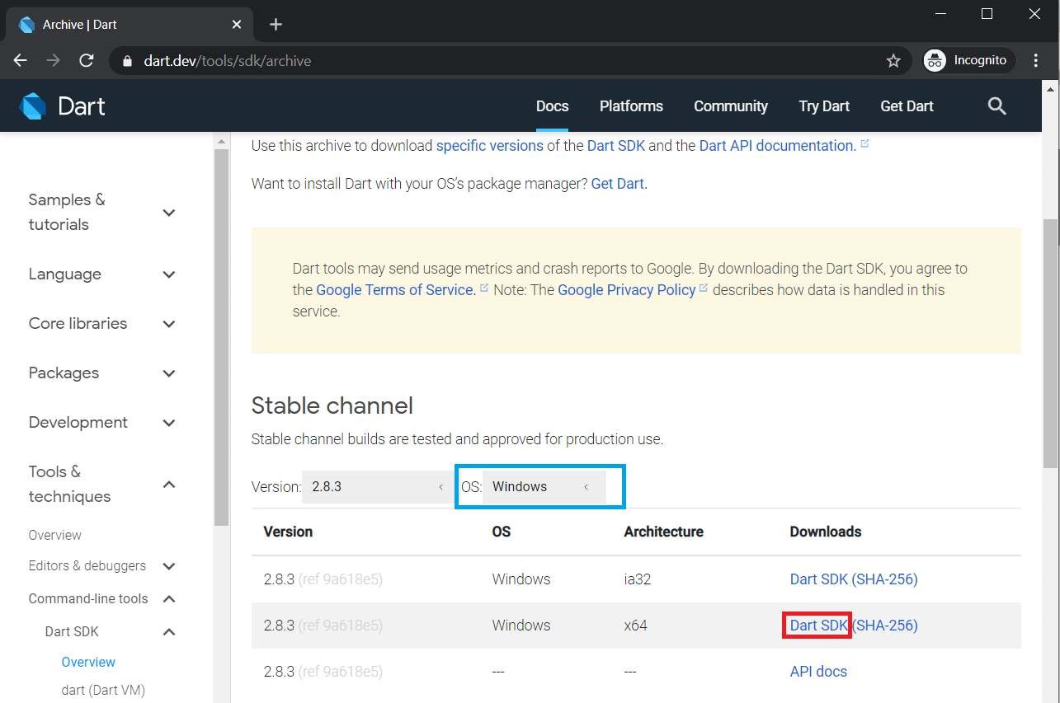

Click on DART SDK to download SDK for Windows 64-Bit Architecture. The download will start and a zip file will be downloaded. **Note:** To download SDK for any other OS select OS of your choice. **Step 2:** Extract the downloaded zip file. Extract the contents of downloaded zip file and after extracting contents of zip file will be as shown:

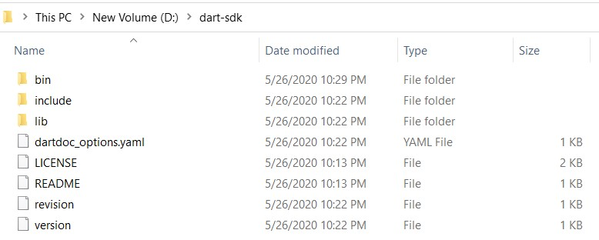

**Step 3:** Running Dart. Now open bin folder and type “cmd” as given below:

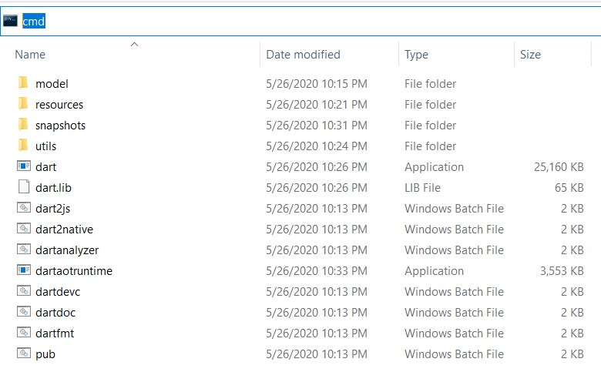

Command Prompt will open with our desired path of bin folder and now type dart”.

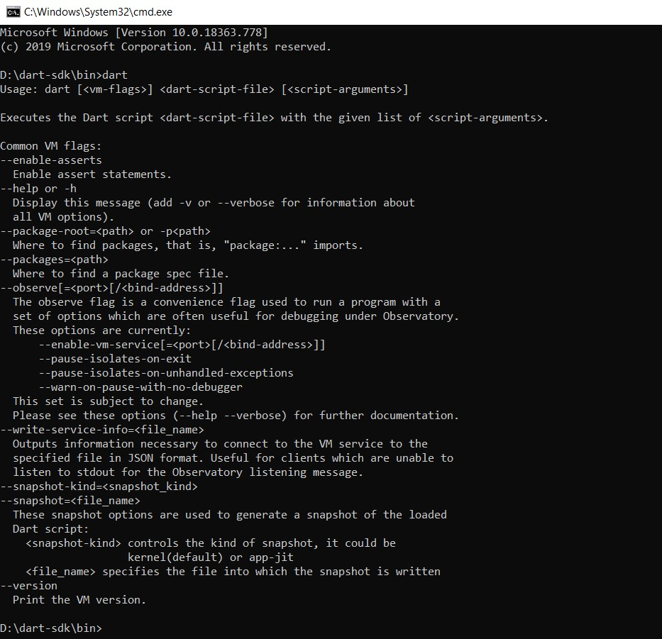

And now we are ready to use dart through bin folder but setting up the path in environment variables will ease our task of Step3 and we can run dart from anywhere in the file system using command prompt.

**Step 4:** Setting up path in environment variables. Open Environment Variables from advanced system settings and add Path in System Variables as depicted in image:

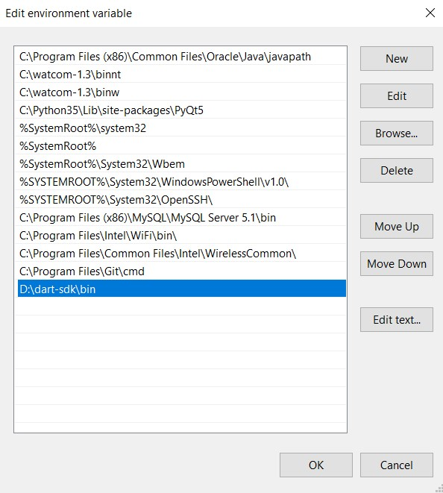

Now we are done to use Dart from anywhere in the file system.

**Step 5:** Run Dart Using cmd

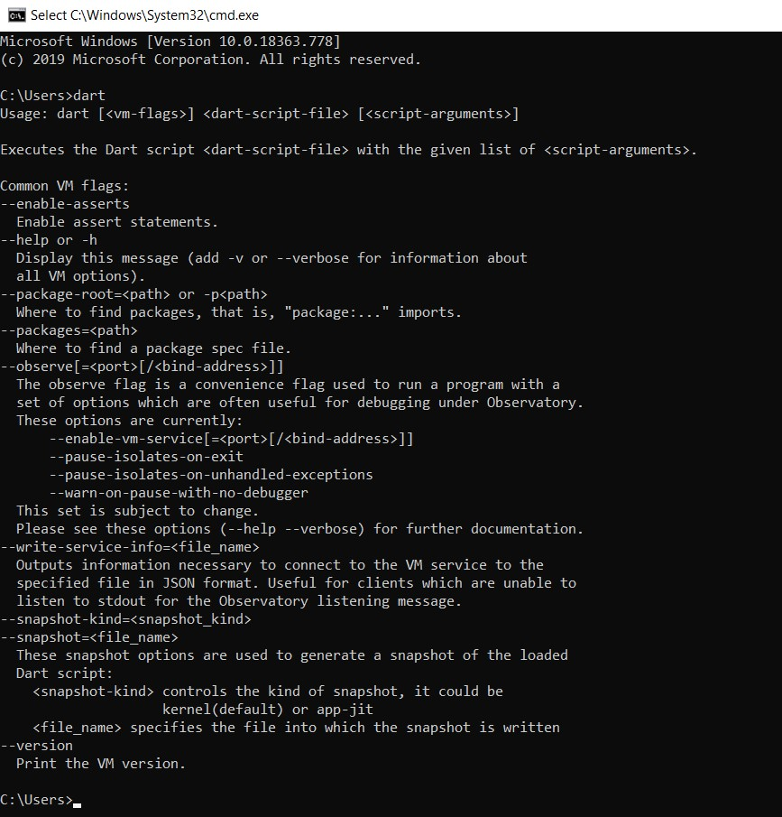

**b) Write a simple Dart program to understand the language basics.**

**Ans)**

void main(){ var firstName = "John"; var lastName = "Doe";

print("Full name is $firstName $lastName");

}

**Output: Full name is John Doe**

void main() { int num1 = 10; //declaring number1 int num2 = 3; //declaring number2

// Calculation int sum = num1 + num2; int diff = num1 - num2; int mul = num1 * num2;

double div = num1 / num2; // It is double because it outputs number with

decimal.

// displaying the output print("The sum is $sum"); print("The diff is $diff"); print("The mul is $mul");

print("The div is $div");

}

**Output:**

**The sum is 13**

**The diff is 7**

**The mul is 30**

**The div is 3.3333333333333335**

import 'dart:io';

void main() { print("Enter number:"); int? number = int.parse(stdin.readLineSync()!); print("The entered number is ${number}");

} **Output:**

**Enter number:**

**50**

**The entered number is 50**

**EXPERIMENT NO: 2.**

**2. a) Explore various Flutter widgets (Text, Image, Container, etc.).**

**Text Widget:**

import 'package:flutter/material.dart';

void main() {

  runApp(

    MaterialApp(

      home: Scaffold(

        backgroundColor: Color.fromARGB(255, 233, 118, 30),

        body: Center(

          child: Text('Hello World',style: TextStyle(

            color: Color.fromARGB(255, 11, 7, 255),

            fontSize: 60,

          ),)

          ),

      ),

    ),

  );

}

**Output:**

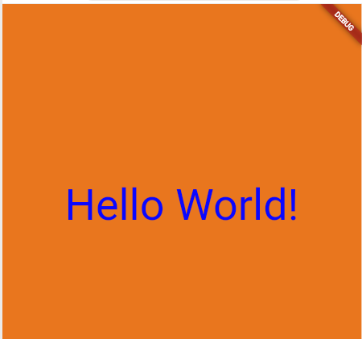

**Image Widget:**

import 'package:flutter/material.dart';

void main() {

  runApp(

    MaterialApp(

      home: Scaffold(

        backgroundColor: Color.fromRGBO(79, 173, 190, 1),

        body: Center(

          child:

 Image.network(

            'https://i.imgur.com/lA89x2h_d.webp?maxwidth=520&shape=thumb&fidelity=high' // Replace with the actual path to your image on your desktop

          ),

        ),

      ),

    ),

  );

}



**Output**

**Containter Widget:**

import 'package:flutter/material.dart';

void main() {

  runApp(

    MaterialApp(

      home: Scaffold(

        appBar: AppBar(

          title: const Text("Container example"),

        ),

        body: Container(

          height: 200,

          width: double.infinity,

          //color: Colors.purple,

 // Uncomment to set background color

          alignment: Alignment.center,

          margin: const EdgeInsets.all(20),

          padding: const EdgeInsets.all(30),

          decoration: BoxDecoration(

            border: Border.all(color: Colors.black, width: 3),

          ),

          child: const Text(

            "Hello! i am inside a container!",

            style: TextStyle(fontSize: 20),

          ),

        ),

      ),

    ),

  );

}

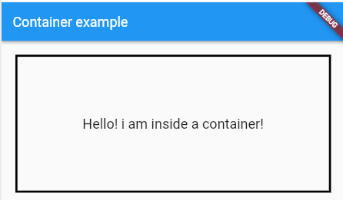

**Output:**

**2b) Implement different layout structures using Row, Column, and Stack widgets Row Widget**

**ROW Widget:**

import 'package:flutter/material.dart';

void main() {

  runApp(

    MaterialApp(

      home: Scaffold(

        appBar: AppBar(

          title: const Text('Technologies'), // Updated title

        ),

        body: Row(

          mainAxisAlignment: MainAxisAlignment.spaceBetween, // Even spacing

          crossAxisAlignment: CrossAxisAlignment.center, // Center alignment

          children: [

            Container(

              width: 100,

              height: 100,

              color: Colors.red, // Red container

              child: const Center(

                child: Text('React.JS'), // Text inside red container

              ),

            ),

            Container(

              width: 100,

              height: 100,

              color: Colors.green, // Green container

              child: const Center(

                child: Text('Flutter'), // Text inside green container

              ),

            ),

            Container(

              width: 100,

              height: 100,

              color: Colors.orange, // Orange container

              child: const Center(

                child: Text('MySQL'), // Text inside orange container

              ),

            ),

          ],

        ),

      ),

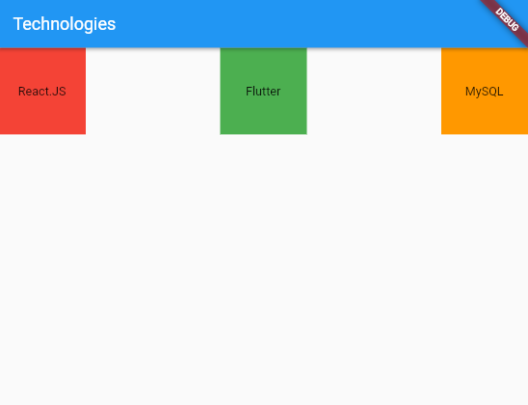    ),

  );

}

**Output:**

**Column Widget:**

import 'package:flutter/material.dart';

void main() {

  runApp(

    MaterialApp(

      home: Scaffold(

        appBar: AppBar(

          title: const Text('Technologies'),

        ),

        body: Column(

          mainAxisAlignment: MainAxisAlignment.spaceBetween,

          crossAxisAlignment: CrossAxisAlignment.center,

          children: [

            Container(

              width: 200,

              height: 100,

              color: Colors.red,

              child: const Center(

                child: Text('React.JS'),

              ),

            ),

            Container(

              width: 200,

              height: 100,

              color: Colors.green,

              child: const Center(

                child: Text('Flutter'),

              ),

            ),

            Container(

              width: 200,

              height: 100,

              color: Colors.orange,

              child: const Center(

                child: Text('MySQL'),

              ),

            ),

          ],

        ),

      ),

    ),

  );

}

Output:

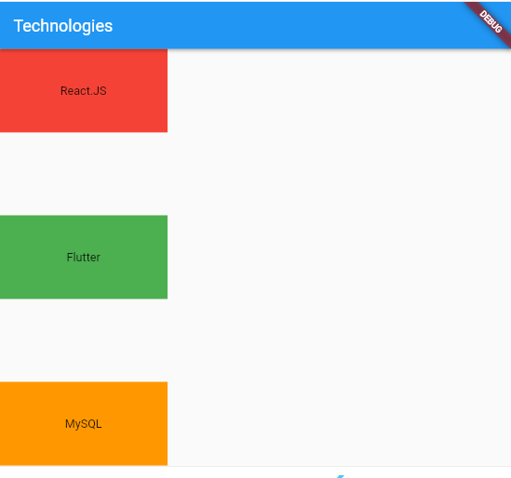

**Stack Widget:**

import 'package:flutter/material.dart';

void main() {

runApp(

MaterialApp(

home: Scaffold(

appBar: AppBar(

title: const Text('Technologies'),

),

body: Stack(

children: [

Container(

width: 200,

height: 200,

color: Colors.red,

child: const Center(

child: Text('React.JS', style: TextStyle(color: Colors.white)),

),

),

Positioned(

top: 10,

left: 10,

child: Container(

width: 180,

height: 180,

color: Colors.green,

child: const Center(

child: Text('Flutter', style: TextStyle(color: Colors.white)),

),

),

),

Positioned(

top: 30,

left: 30,

child: Container(

width: 150,

height: 150,

color: Colors.orange,

child: const Center(

child: Text('MySQL', style: TextStyle(color: Colors.white)),

),

),

),

],

),

),

),

);

}

**Output:**

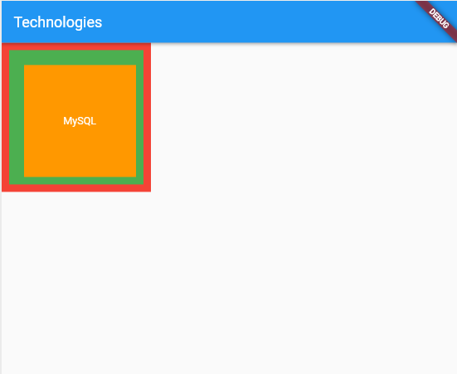

**EXPERIMENT NO: 3.**

**3. a) Design a responsive UI that adapts to different screen sizes.**

**Ans)**

import 'package:flutter/material.dart';

void main() {

  runApp(

    MaterialApp(

      home: Scaffold(

        appBar: AppBar(

          title: Text('Responsive UI'),

        ),

        body: OrientationBuilder(

          builder: (context, orientation) {

            return LayoutBuilder(

              builder: (context, constraints) {

                if (constraints.maxWidth

 < 300) {

                  // Layout for smaller screens (portrait mode)

                  return Column(

                    crossAxisAlignment: CrossAxisAlignment.start,

                    children: [

                      Container(

                        color: Colors.blue,

                        padding: EdgeInsets.all(16.0),

                        child: Text('Left Content'),

                      ),

                      Container(

                        color: Colors.green,

                        padding: EdgeInsets.all(16.0),

                        child: Text('Right Content'),

                      ),

                    ],

                  );

                } else {

                  // Layout for larger screens (landscape mode)

                  return Row(

                    crossAxisAlignment: CrossAxisAlignment.start,

                    children: [

                      Expanded(

                        flex: 3,

                        child: Container(

                          color: Colors.blue,

                          padding: EdgeInsets.all(16.0),

                          child: Text('Left Content'),

                        ),

                      ),

                      Expanded(

                        flex: 2,

                        child: Container(

                          color: Colors.green,

                          padding: EdgeInsets.all(16.0),

                          child: Text('Right Content'),

                        ),

                      ),

                    ],

                  );

                }

              },

            );

          },

        ),

      ),

    ),

  );

}

**Output:**

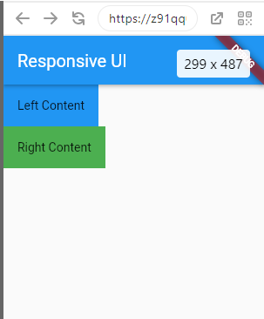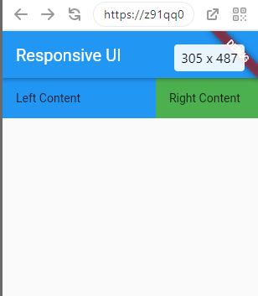

**3 b) Implement media queries and breakpoints for responsiveness.**

Ans import 'package:flutter/material.dart';

void main() {

  runApp(

    MaterialApp(

      home: Scaffold(

        appBar: AppBar(

          title: Text('Responsive UI with MediaQuery'),

        ),

        body: Builder(

          builder: (context) {

            var screenWidth = MediaQuery.of(context).size.width;

            if (screenWidth < 300) {

              // Layout for smaller screens (portrait mode)

              return Column(

                crossAxisAlignment: CrossAxisAlignment.start,

                children: [

                  Container(

                    color: Colors.blue,

                    padding: EdgeInsets.all(16.0),

                    child: Text('Left Content'),

                  ),

                  Container(

                    color: Colors.green,

                    padding: EdgeInsets.all(16.0),

                    child: Text('Right Content'),

                  ),

                ],

              );

            } else {

              // Layout for larger screens (landscape mode)

              return Row(

                crossAxisAlignment: CrossAxisAlignment.start,

                children: [

                  Expanded(

                    flex: 3,

                    child: Container(

                      color: Colors.blue,

                      padding: EdgeInsets.all(16.0),

                      child: Text('Left Content'),

                    ),

                  ),

                  Expanded(

                    flex: 2,

                    child: Container(

                      color: Colors.green,

                      padding: EdgeInsets.all(16.0),

                      child: Text('Right Content'),

                    ),

                  ),

                ],

              );

            }

          },

        ),

      ),

    ),

  );

}

Output:

**EXPERIMENT NO: 4.**

**4. a) Set up navigation between different screens using Navigator.**

import 'package:flutter/material.dart';

void main() {

  runApp(MaterialApp(

    home: Builder(

      builder: (context) => Scaffold(

        appBar: AppBar(

          title: Text('Navigation Example'),

        ),

        body: Center(

          child: Column(

            mainAxisAlignment: MainAxisAlignment.center,

            children: [

              Text('Welcome to the Home Screen'),

              ElevatedButton(

                onPressed: () {

                  Navigator.push(

                    context,

                    MaterialPageRoute(

                      builder: (context) => Scaffold(

                        appBar: AppBar(title: Text('About Screen')),

                        body: Center(

                          child: Column(

                            mainAxisAlignment: MainAxisAlignment.center,

                            children: [

                              Text('This is the About Screen'),

                              ElevatedButton(

                                onPressed: () {

                                  Navigator.pop(context);

                                },

                                child: Text('Go to Home'),

                              ),

                            ],

                          ),

                        ),

                      ),

                    ),

                  );

                },

                child: Text('Go to About'),

              ),

            ],

          ),

        ),

      ),

    ),

  ));

}

**Output:**

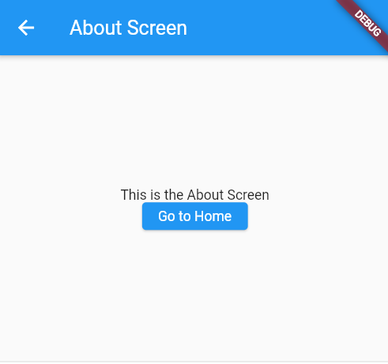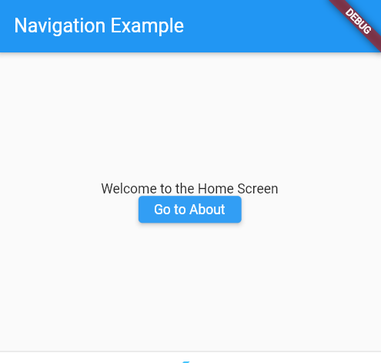

**4b) Implement navigation with named routes.**

**Ans)**

import 'package:flutter/material.dart';

void main() {

  runApp(

    MaterialApp(

      initialRoute: '/',

      routes: {

        '/': (context) => Scaffold(

              appBar: AppBar(title: Text('Navigation Example')),

              body: Center(

                child: Column(

                  mainAxisAlignment: MainAxisAlignment.center,

                  children: [

                    Text('Welcome to the Home Screen'),

                    ElevatedButton(

                      onPressed: () {

                        // Navigate to the About Screen using named route

                        Navigator.pushNamed(context, '/about');

                      },

                      child: Text('Go to About'),

                    ),

                  ],

                ),

              ),

            ),

        '/about': (context) => Scaffold(

              appBar: AppBar(title: Text('About Screen')),

              body: Center(

                child: Column(

                  mainAxisAlignment: MainAxisAlignment.center,

                  children: [

                    Text('This is the About Screen'),

                    ElevatedButton(

                      onPressed: () {

                        // Navigate back to Home Screen

                        Navigator.pop(context);

                      },

                      child: Text('Go to Home'),

                    ),

                  ],

                ),

              ),

            ),

      },

    ),

  );

}

**Output:**

